Press Release – June 1th, 2005

For more info or interviews contact:

Felicity Gerwing 206-947-0436 email: swaranjaliproductions@yahoo.ca

From the eternal city of Benares, India
Swaranjali Productions presents the summer concert tour of
Master Sitarists and Vocalists
‘Pandit’ Shivnath Mishra
and son Deobrat Mishra

with Marco Zonka on tabla

India’s acclaimed father-son sitar duo “The Mishras” are coming to North America for their 2005 summer tour. From their home city of Benares, an ancient spiritual centre of traditional music and Hindu culture, they bring Classical North Indian Ragas and folk music to communities throughout British Columbia and the Pacific Northwest. These seasoned musicians have been sharing the magic and joy of their musical presence for over twenty years in India, Europe, Canada and the US, to critical and award winning acclaim. The ensemble for their 2005 tour includes renowned tabla player, Marco Zonka of Seattle and Felicity Gerwing of the Kootenays on tamboura.
‘Pandit’ (meaning master) Shivnath and his son Deobrat Mishra keep alive the musical tradition of ‘raga’, one of the oldest improvisatory and devotional musical forms. Pandit Shivnath Mishra, seventh generation “Benare’s Style” musician, recording artist, and head of the music department at Sanskrit University in Benares, has toured extensively bringing his masterful, mischievous, joyful presence and playing style to the delight and amazement of audiences everywhere. Deobrat Mishra, received the Jewels of Sound award (the Indian ‘Grammy’) in Mumbai, and recently also received his Masters Degree in sitar while continuing to tour and record internationally with his father and others.
Like indigenous cultural arts all over the world, the traditional music of India faces unique challenges. With the ascendance of Western and Eastern popular music, and the pervasive influence of ‘Bollywood’ songs, sacred and traditional music is increasingly marginalized. To keep the music tradition growing and alive, the Mishras began teaching music in their home. Early this spring, near the banks of the Ganga River in Benares - one of the oldest and continually inhabited cites on earth - a hundred men climbed up and down scaffolding in the hot sun and poured, in one day, bucket by bucket, the concrete slab of the first-floor roof over the new Academy of Classical Indian Music. Pandit Shivnath Mishra and his family have opened their new music academy to students and children of any caste or family circumstances who wish to learn their rich Benares ‘Gharana’, or “ancestral tradition”. To support these efforts, Pandit Shivnath Mishra and Deobrat Mishra travel every summer and perform throughout North America.
This is an amazing opportunity for North American audiences to experience “ragas”, as vibrant in the hands of these living masters as they were in the hands of the ancients. Experience for yourself the magic and mystery of ‘raga’.

“…it was the best performance I’ve ever seen.” Ascent Magazine 2001

Biographies
‘Pandit’ Shivnath Mishra was born into a well-known musical family in the 'Benares 'Gharana' (ancestral lineage) in 1943. At five years old he began studying vocal music with his father Badar Prasad Mishra and his uncle and guru Pandit (master musician) Mahadev Prasad Mishra. When he was eight years old he began studying sitar. In a family of many fine classical Indian vocalists, he is the first to master the sitar, playing it in 'Thumari' style, characterized by a strong emphasis on melody and deep emotion. In 1966 he received a gold medal in the All India Music Conference in Calcutta. He performed in Germany for the first time in 1979 and has since played extensively throughout Europe and in 1999 played his first North American concert tour. Pandit Shivnath Mishra is well known on All India Radio and Television, and has performed beside many of India's great musicians including Kishan Maharaj, Samta Prasad, Sharda Sahai, Laccu Maharaj and Ashish Khan. He has also performed with jazz artists such as John Handy, Paul Horn, David Freezen and Ben Conrad. At present, he is a lecturer and the head of the music department at Sampurnand Sanskrit University, Varanasi.

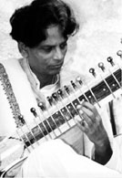

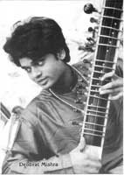
Deobrat Mishra, a musical luminary in his own right, is one of India's premiere and promising young sitar artists, chosen in 1995 by All India Radio to receive the award of Best Young Sitarist in India. Born in 1976, Deobrat is a seventh generation musician in the Mishra's branch of the 'Benares Gharana,' - meaning musical family tradition or lineage .As a young child he studied tabla with his mother Pramila, granddaughter of the well-known tablist Baiju Mishra, and also studied vocal music before beginning sitar with his father at age five. At age six he gave his first performance, and at age eleven performed for his first time on All India Radio. Since 1994 he has toured throughout Europe with his father, and his many projects include music Workshops, solo performances for radio and television, and world music with a group of Indian and European artists. Deobrat Mishra received the Jewels of Sound award in Mumbai (the Indian ‘Grammy’). He recently received his Masters Degree in sitar from the Prayag Sangit Samiti in Allahbad, and continues to tour with his father.

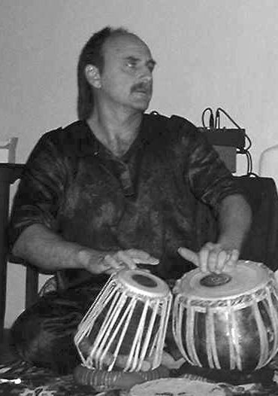
Marco Zonka began studying tabla in 1977 with the late Ustad Allah Rakha at the Indian Cultural Arts Ashram in San Francisco. He continued studies of Indian vocal and instrumental music with Ustad Ali Akbar Khan at the Ali Akbar college of music in San Rafael, and with resident tabla maestros Ustad Zakir Hussain and Pandit Swapan Chaudury. Marco plays and performs numerous finger-drumming styles, including tabla, tar, bendir, dhumbek and udu drums. He also composes and performs original vocal and percussion music.

A Brief History of Hindustani Music:

The origin of classical music can be traced back to the spiritual temples of India in Vedic times- nearly five thousand years. Some say it is far older than that. Sanskrit writings ascribe its genealogy to a period in remote antiquity. They say that this music was originally “the music of the gods.”
From these sacred points of origin it traveled over many centuries into temples throughout the Indian subcontinent. It eventually arrived into the palaces of the kings and queens of India, who were among its most avid patrons. The music of the temples, adapting to it’s changing environment in the worldly courts of the kings, began to also express the majestic and earthly sensibilities of the imperial court. Later, in the reign of the Persian and Muslim kings, the music was enriched by the playful and improvisatory aires favored by the Persian and Islamic musical masters. The genius of the sacred and ecstatic music of Persia began blending with the sacred and majestic music of India. Much of the sense of mystery and alluring depth that the listener experiences in this music comes from this dynamic blend; an alchemy of the sacred embracing the senses. The Persian embracing the Hindu. The sensual and spiritual elements of life so naturally joined in sacred song.
Like indigenous cultural arts all over the world, the traditional music of India faces unique challenges in these changing times. With the rising popularity of both Western and Eastern popular music, and the pervasive influence of film industry music in India, sacred and traditional music is increasingly marginalized and diluted. Many years ago the Mishra’s began giving music instruction in their home to students and children interested in learning to play classical Indian music. Many of these children come from families that cannot afford to send their children to music school. The Mishra’s support educating these children in the hope of both developing the child in their desire for musical learning, and to keep the music tradition itself growing and alive. ‘Pandit’ Shivnath Mishra and his family recently opened their Academy of Classical Indian Music, open to all children of any caste or family circumstances who wish to learn their rich Benares Gharana, or “ancestral tradition.” This tour is to bring the Mishras and their music to appreciative Western audiences and to support the academy.

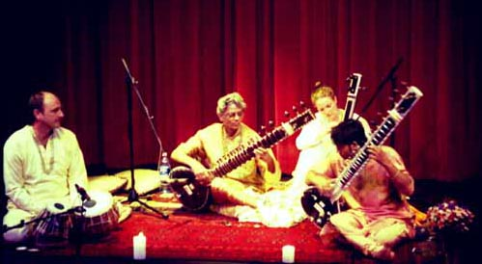

For a musical demo and full tour schedule visit: www.music-of-benares.com
For interviews or bookings contact:

S w a r a n j a l i P r o d u c t i o n s 

Felicity Gerwing – North American Tour Director
Email: swaranjaliproductions@yahoo.ca Ph: 250-226-7346 cell: 206-947-0436
or Marco Zonka marco@zonka.org Ph: 360-301-3833

Press Quotes on the Mishras

“Varanasi’s music tradition has produced many great sitar artists including Pandit Ravi Shankar and Mustaq Ali Khan. Among its new generation, Pandit Shivnath Mishra is keeping the tradition going”
Swatantra Bharat, 7 December 1986

“An imaginative and thoughtful performance which shows that he is a great artist.”

Dainik Jagaran – 1993

“Pt. Shivnath Mishra has taken his place among the leading artists of Benares. His performance was joyful, powerful and full of sweetness.”

National Sahara News – May 2, 1994

“By exploring new paths Deobrat Mishra will bring about a revolution in Indian Classical music”

Hindustan Times 1997

“The Mishras, father and son, displayed a rare understanding between themselves and of the unique Benaras musical style”

Bombay News 1999

“The surrender in the Mishras playing allowed the music to flow unimpeded through graceful fingers into the theatre…it was the best performance I’ve ever seen.”

Ascent Magazine 2001

“Don’t miss the Mishras, because their music is magic.”

Kitchener/Waterloo Record – June 2002

“Don’t miss your chance to see the amazing collaboration of the Mishras…relax, clear your mind and let the music take over.”

Amy Kepferle, Bellingham Weekly, July 2003

“Father and son had an amazing connection with each other. They created an incredible cascade of sound that sent ecstatic tremors through the space and transformed the audience. It was as if they and their instruments became one. The audience gave them a standing ovation.”

Radha House, Spokane 2003

“Their playing is emotional, juicy, full of ‘rasa’! It’s rustic, primitive, pagan and almost vocal.”
Olof Soderback

Ashland, Oregon 2004

